* *How many gates are used in the implementation of the Xor gate in the Nissan and Schocken textbook?*
  + 5 gates are used. 2 NOT gates, 2 AND gates, and 1 OR gate are used in the textbook to implement XOR gate. But as the textbook explains, the implementation patterns of logic gate are not limited to the unique one. It is also possible to implement with 4 gates. The way of implementation depends on what is the main focus of the implementation. There is a cost-centric pattern or speed-centric pattern or simplicity-centric pattern and so forth.
  + 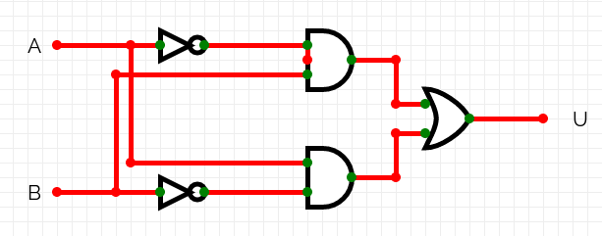
* *Present your implementation to the Xor chip. How many gates are there in your implementation?*
  + Here is my implementation with 4 logic gates. 2 AND gates, 1 NOT gate, 1 OR gate.
  + 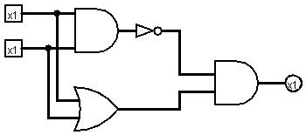
* *Please use engineer's logic and your textbook to answer the following:*
  + *Can you think of a more efficient implementation?*
    - If the word of efficiency can be defined as the number of gates used for an implementation, I guess the implementation with 4 gates written above are the most efficient. As the textbook says that, “from an efficiency standpoint, the general rule is to try to do more with less, that is, use as few gates as possible”, it can be true from one aspect of efficiency (Nisan & Schocken, 2005).
  + *Efficiency is not necessarily the number of gates used. It's all about "following the money." In other words, what does it cost to implement a new gate?*
    - On the contrary to the statement above, the efficiency includes many aspects. One of the most major aspects must be a cost. Cost is comprised of human resource cost, time cost, and monetary cost and so on. So, if XOR gate with 4 gate is not common in the market, it can be more expensive for factory to produce in large quantities. It might be difficult to create a new template for XOR gate with 4 gates. Or there might not be enough skillful talents in the market who are familiar with the one with 4 gates, which means an expensive salary and difficulty to hire them. In conclusion, following the money means taking many aspects into consideration, not only the number of primitive gates used.